Select output file, select Template as BRIDG Model Report, select Table of Contents to be Portrait, no Stylesheet, Coverpage is Cover – Portrait - BRIDG Model Report, output Format is PDF, no diagram theme, then click Options tab and see next screen shot

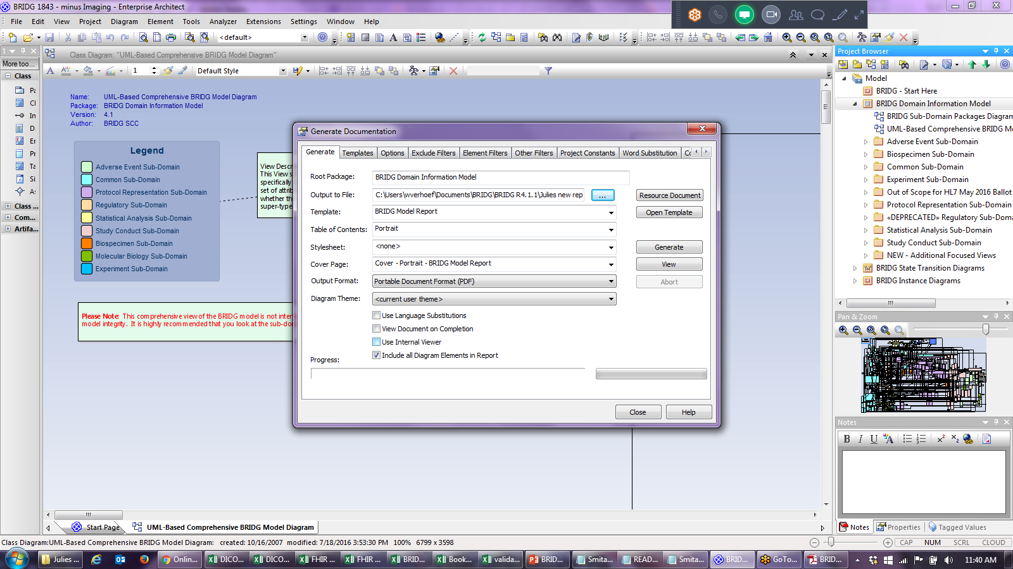

Hide anonymous elements and then go back to Generate tab and click Generate button:

